MODULE 1

Q1 https://www.hackerearth.com/practice/basic-programming/input-output/basics-of-input-output/practice-problems/algorithm/io-exercise/
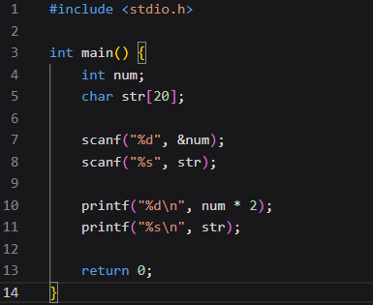

Q2 https://www.hackerrank.com/challenges/solve-me-first/problem
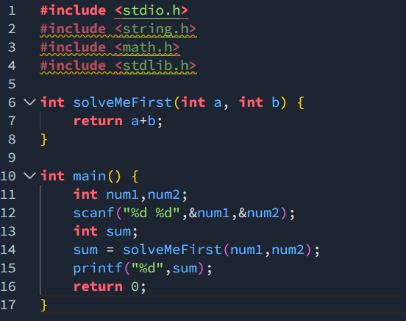
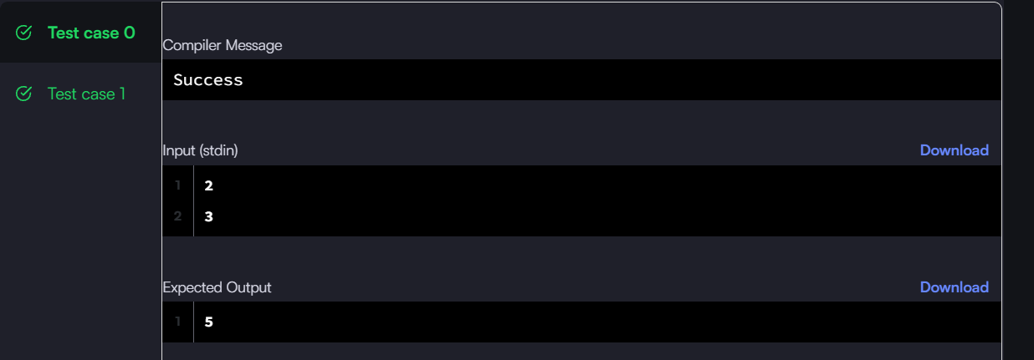
Q3 https://leetcode.com/problems/add-two-integers/
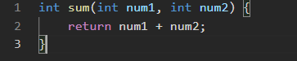


Q4 https://leetcode.com/problems/calculate-delayed-arrival-time/
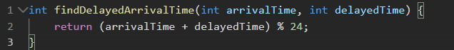


Q5 https://leetcode.com/problems/total-distance-traveled/
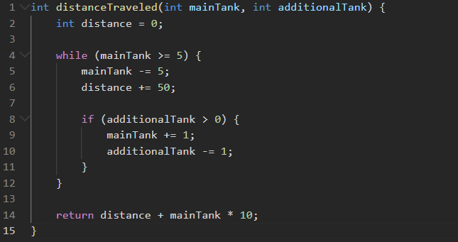
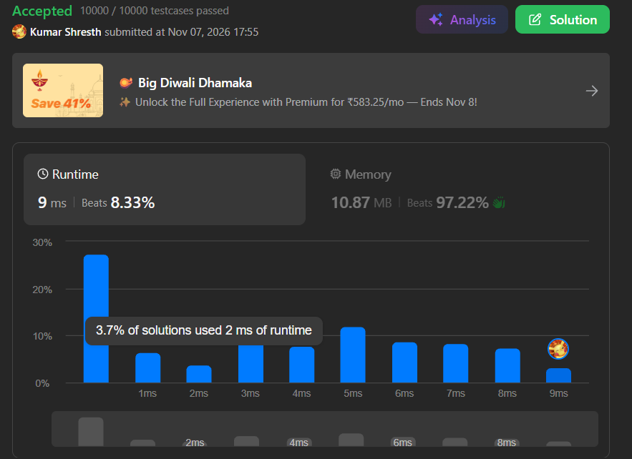

MODULE 2
Q1 https://www.hackerrank.com/challenges/conditional-statements-in-c/problem
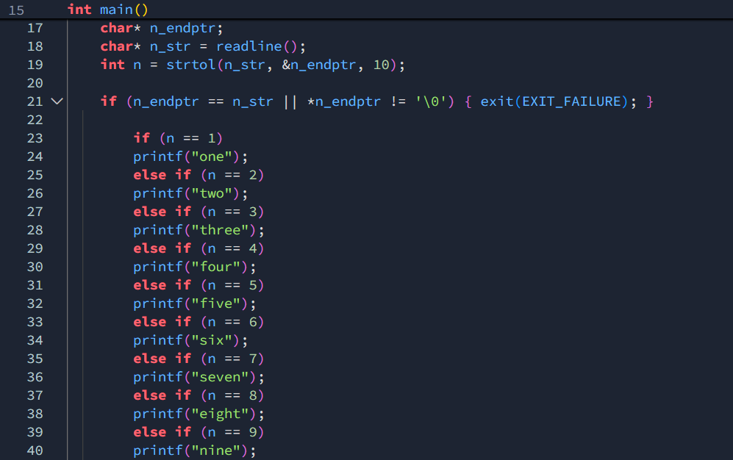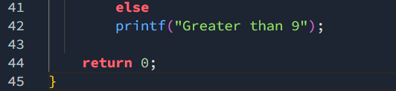


Q2 https://leetcode.com/problems/smallest-even-multiple/
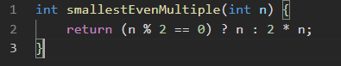


Q3 https://www.hackerrank.com/challenges/grading/problem

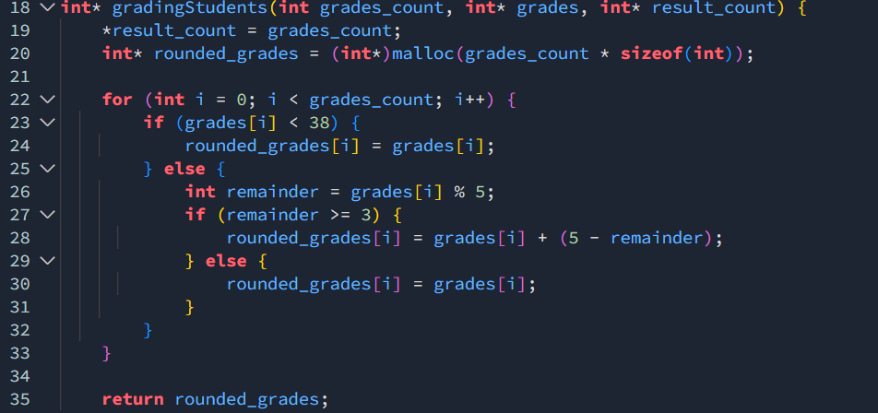
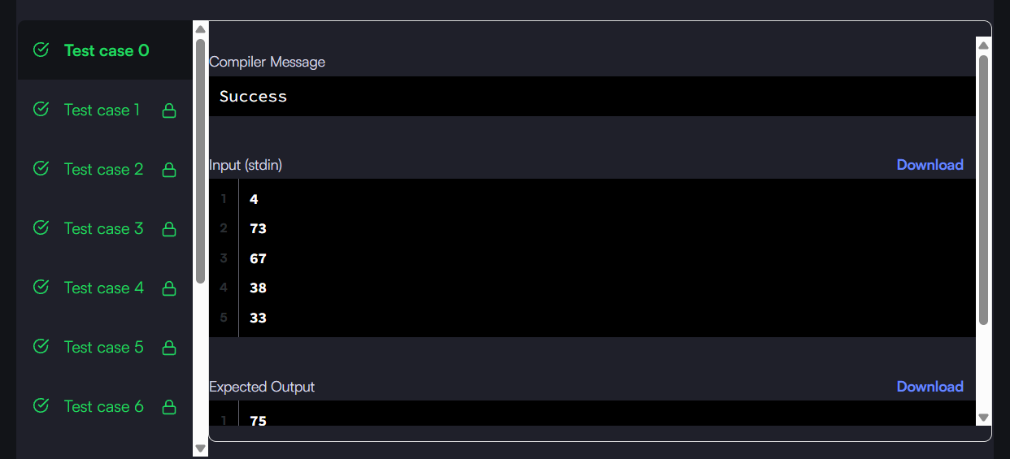

Q4 https://www.hackerearth.com/practice/basic-programming/input-output/basics-of-input-output/practice-problems/algorithm/roy-and-profile-picture/
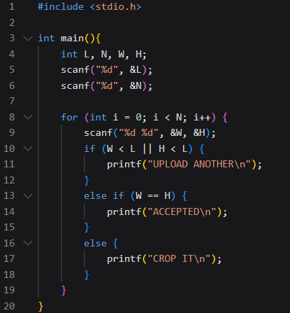
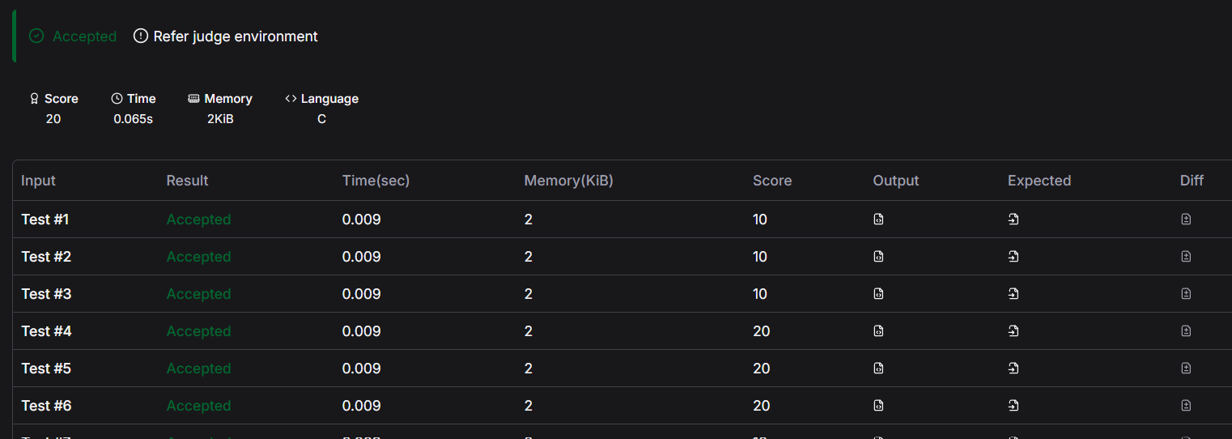

Q5 https://www.hackerrank.com/challenges/fizzbuzz/problem

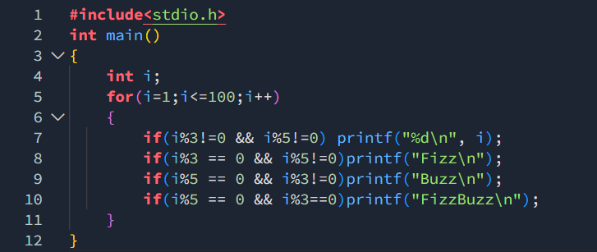


MODULE 3
Q1 https://www.hackerrank.com/challenges/for-loop-in-c/problem
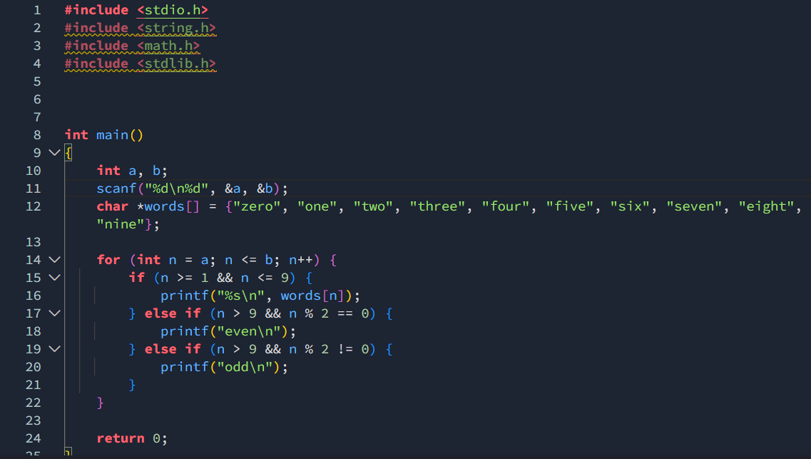
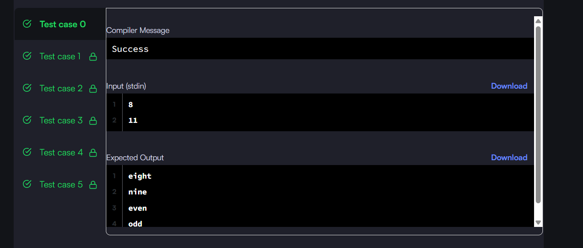

Q2 https://leetcode.com/problems/number-of-steps-to-reduce-a-number-to-zero/

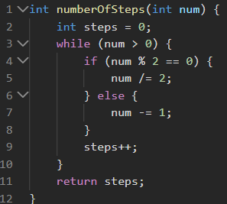
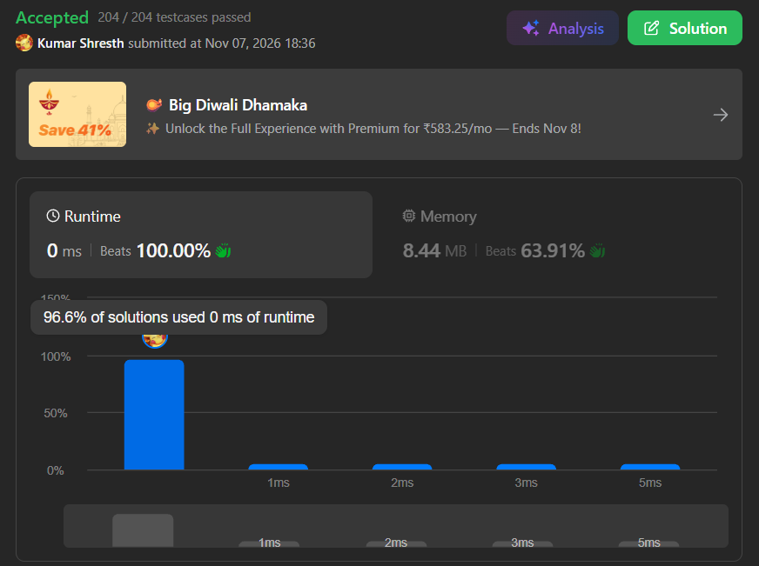

Q3 https://leetcode.com/problems/count-operations-to-obtain-zero/
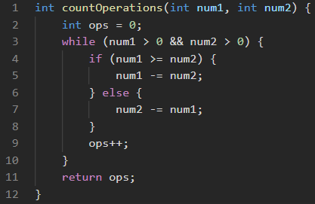
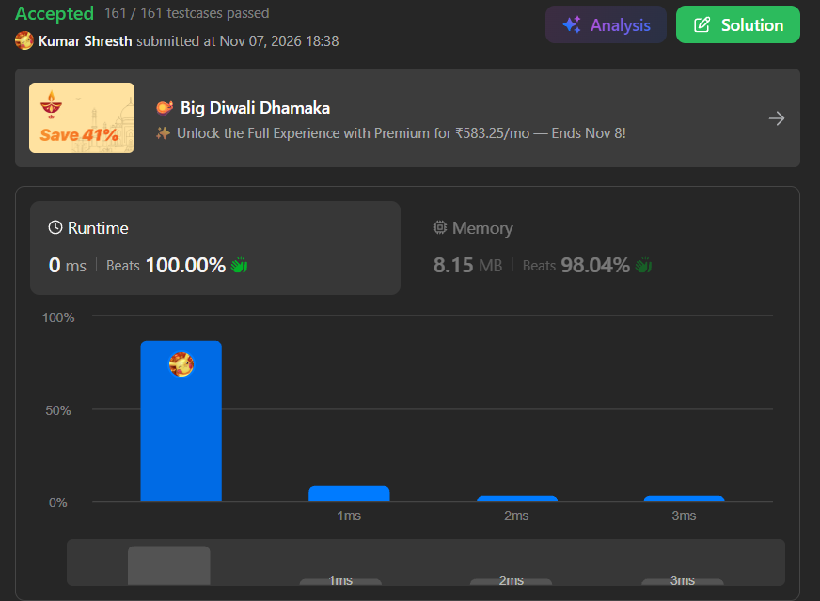

Q4 https://leetcode.com/problems/count-odd-numbers-in-an-interval-range/
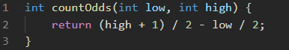
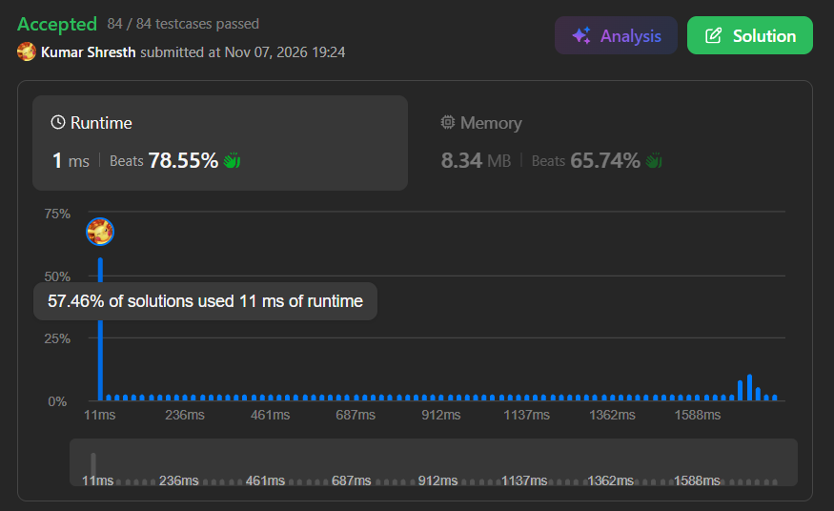

Q5 https://leetcode.com/problems/sum-multiples/
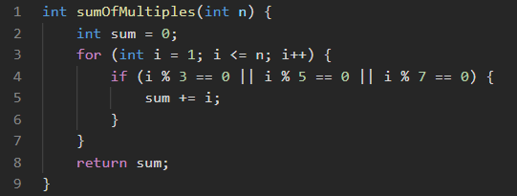


Q6 https://www.hackerrank.com/challenges/kangaroo/problem
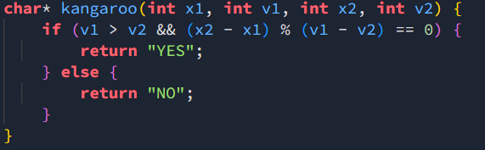


MODULE 4
Q1 https://www.hackerearth.com/problem/algorithm/digit-sum-4/
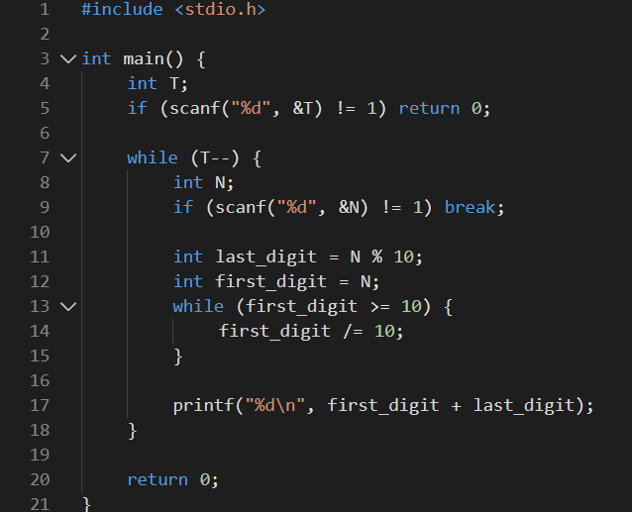
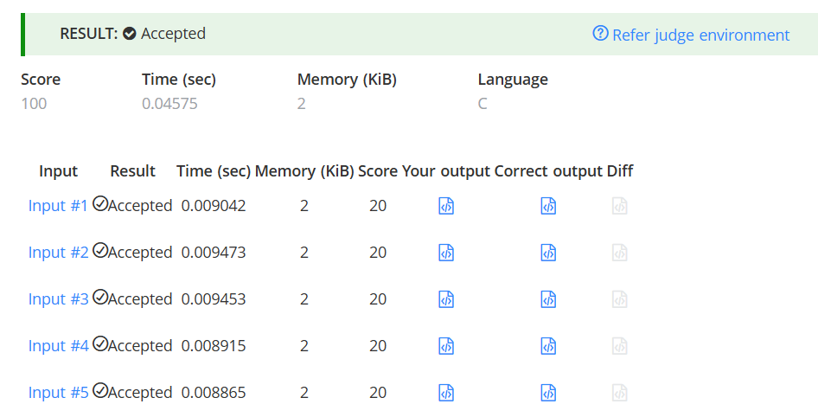

Q2 https://www.hackerrank.com/challenges/find-digits/problem
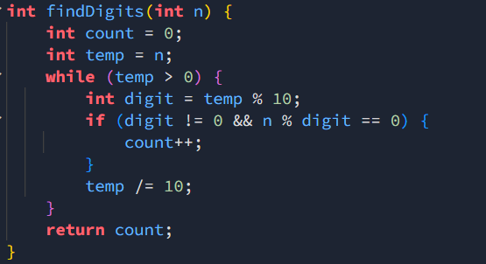

Q3 https://leetcode.com/problems/subtract-the-product-and-sum-of-digits-of-an-integer/
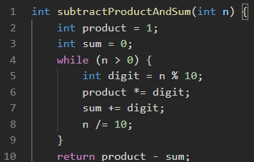

Q4 https://leetcode.com/problems/count-the-digits-that-divide-a-number/
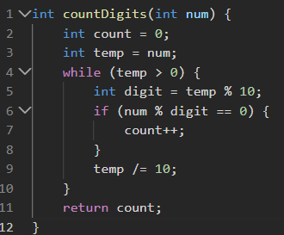


Q5 https://leetcode.com/problems/palindrome-number/
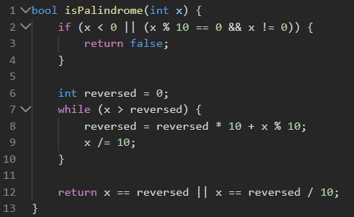


Q6 https://leetcode.com/problems/reverse-integer/

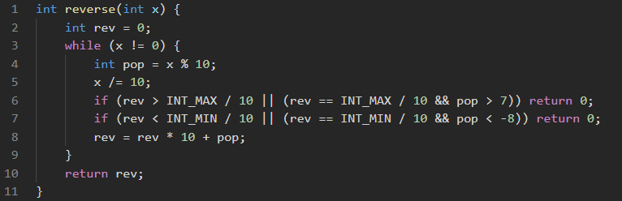


MODULE 5
Q1 https://leetcode.com/problems/power-of-two/
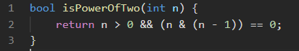


Q2 https://leetcode.com/problems/power-of-three/
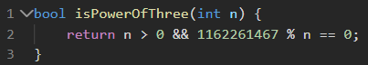


Q3 https://www.hackerearth.com/practice/basic-programming/input-output/basics-of-input-output/practice-problems/algorithm/find-factorial/
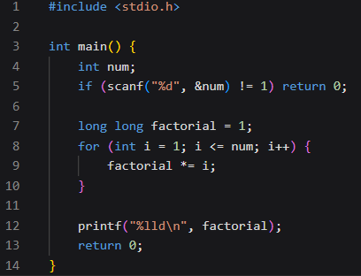


Q4 https://www.hackerearth.com/practice/basic-programming/input-output/basics-of-input-output/practice-problems/algorithm/count-divisors/

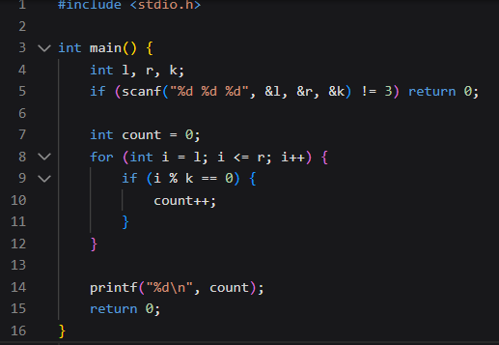


Q5 https://www.hackerearth.com/problem/algorithm/prime-numbers/
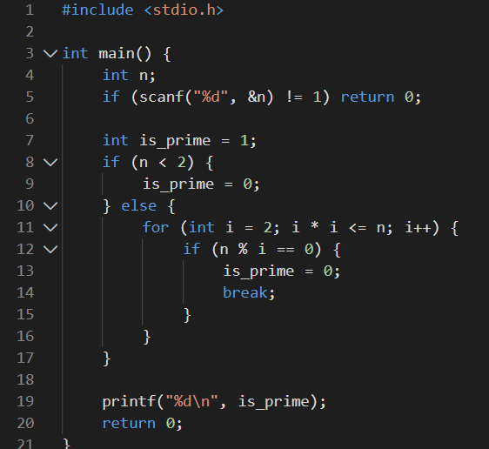
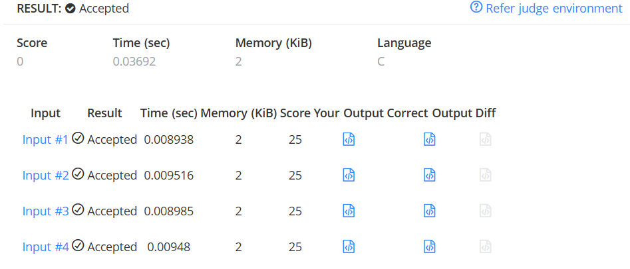

Q6 https://leetcode.com/problems/perfect-number/
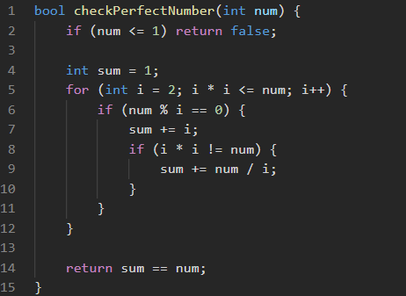


MODULE 6
Q1 https://www.hackerrank.com/challenges/staircase/problem
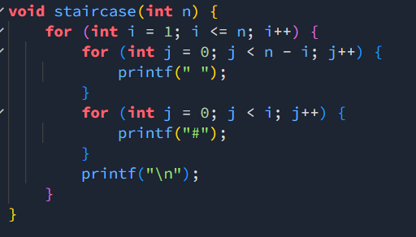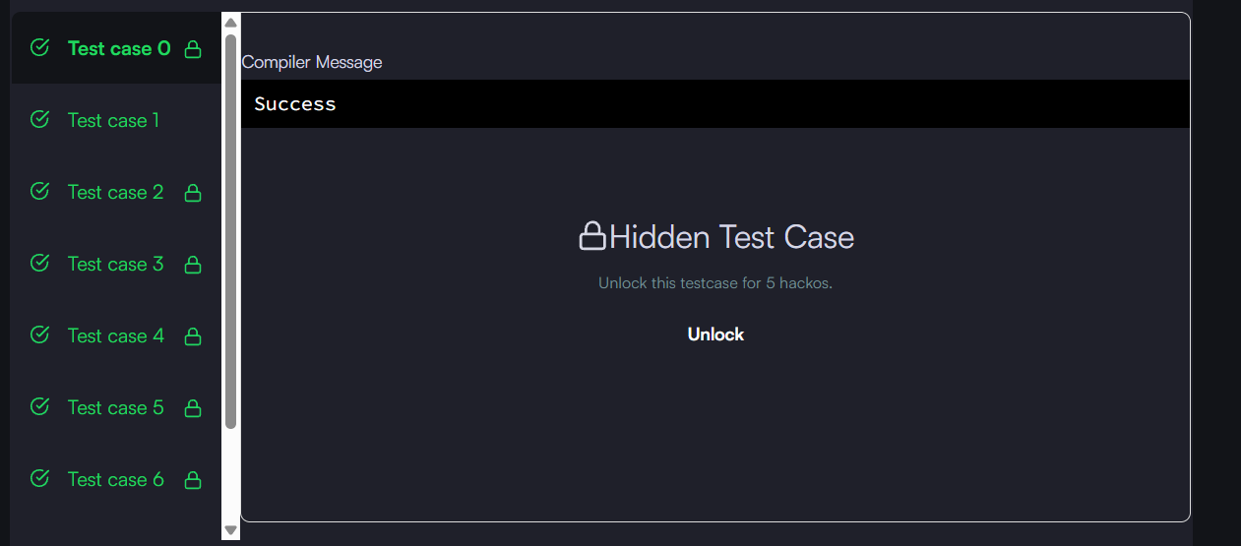

Q2 https://www.hackerrank.com/challenges/printing-pattern-2/problem




